CENTRAL TENDENCY REPORT

(PLACEMENT DATA)

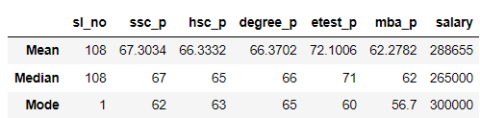

* From 10Th Standard to Degree, The students have average performance of 66%
* Only in the Entrance test they performed above Average of 72%
* Again in MBA they performed only average of 62%
* So,as per MEAN result average salary is Rs.288655
* There is an outlier in median .So,there is a difference in salary of Rs.265000
* Mode of ssc_p :62
* Mode of hsc_p :62
* Mode of degree_p :65
* Mode of etest_p :60
* Mode of mba_p :56.7
* Mode of salary :300000
* Overall class performance result is AVERAGE
* Overall average salary is 300000